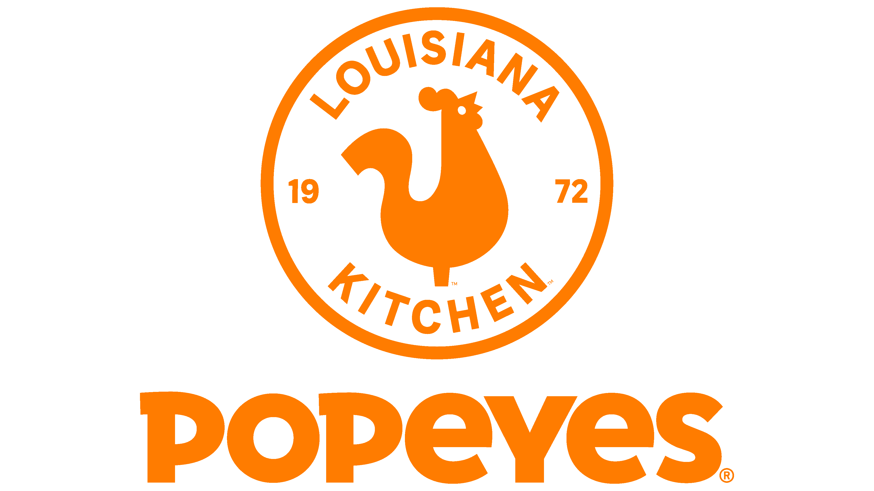 POPEYES WEEKLY DELIVERY & OPERATION CASE STUDY

Popeye’s UK, Our Store Weekly Delivery & Operation Performance Analysis.

Objective : Popeyes restaurant wants to analyse its delivery and operations performance over a week to:
1. Track sales across multiple delivery platforms (Deliveroo, Uber Eats, Just Eat).
2. Compare projected vs actual sales.
3. Monitor KPIs like refunds %, online time %, customer ratings, ATV, service times, large meals served.
4. Identify trends and areas for improvement.
Data Overview:
Delivery Data: Sales per platform, refunds %, online time %, customer ratings
Operations Data: Projected vs actual sales, differences, target, ATV, large meals, service times.
Analysis Goals:
- Determine which delivery platform performs best.
- Track daily sales vs projections.
- Identify days with higher refunds or lower operational efficiency.
- Monitor customer satisfaction and service KPIs.
Insights & Recommendations:
1. Sales Performance:
- Identify the best-performing platform each day.
- Track total weekly sales and compare with projections.
2. Refunds & Online Time:
- Monitor days with higher refunds to identify operational issues.
- Ensure online availability stays close to 100%.

3. Customer Ratings:
- Maintain high ratings across all platforms.
- Investigate any sudden drops in ratings.
4. Operational KPIs:
- Track ATV trends to improve sales efficiency.
- Monitor large meals served and service times to optimize kitchen operations.

Conclusion:
Using this weekly delivery and operations data, Popeye’s can make informed decisions to improve sales, operational efficiency, and customer satisfaction. Implementing a Power BI dashboard will help visualize trends, compare platforms, and monitor key performance indicators in real time.

